3/19/2021

PATTERN CHECK LIST FOR SENDING OUT TO FACTORY AND ADVISING YY

**General:**

Make sure all grain lines are correct.

Walk every seam – make sure connecting pattern pieces continue smooth line.

Make sure notches match

Mirror pieces to ensure they are symmetrical

Make sure all pieces are clearly named.

Pattern should say “Base Size”

Open all cuffs and plackets - any pieces on the fold.

Add 5” square – do not add square in YY

**Shirring:**

Check all shirring is same ratio or required ratio matching tech set up or let tech know if different.

Add all pattern markings for shirring. If chance unclear what it is shirred to, mark seam with note or finished shirring size between notches. Shirring noted with curved snake line.

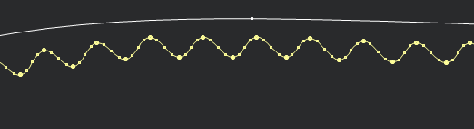

**Slopers:**

Add sloper pieces for finished neckline and armhole size whenever different from flat pattern

Example if there is front or back shirring along neck held by binding. Finished shirring size must be known.

Add sloper for finished cut elastic length or call out to tech to advise.

Add sloper for finished binding length when needed.

**Binding pieces**:

for ¼” finish – pieces should be 1 ¼” wide for heavy stable fabrics and 1 ½” wide for soft stretchy fabrics. Make bias piece longer than needed, +1” for 10”, +2” for 10” to 15”. +3” for 15” , etc.

Example. finish neck circumference is 30” make binding piece 1 ¼” x 36” for marker YY.

Binding pieces for straps with an adjuster: add +6” to length for adjustable fold and loop.

Add sloper for cut smocking pieces:

**Smocking:** Please always make cut sloper size for relaxed smocking - This piece does not go in the marker for YY. Make block for smocking panel for marker

Smocking Block: Add +3” to height, add x3 to width. Example below, smaller piece is finished sloper, larger piece is block for smocking.

3 to 1 shirring is safe guess for factory machines

Addition to height allows for cutting.

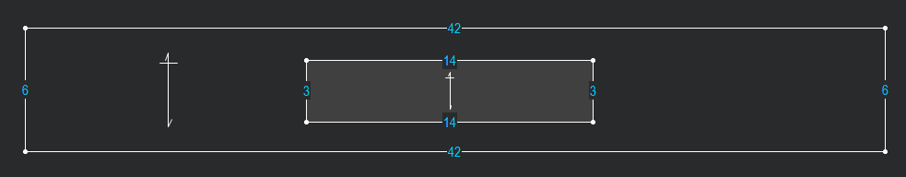

**Darts:**

Dart cannot be cut out unless over 2+ deep intake. Over +2” intake add seam allowance to dart. Give correct pattern outline shape to dart. Draw dart legs with internal line if not using Optitex dart function.

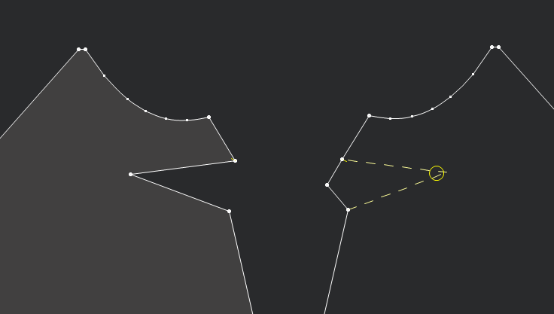

**Button Marks:**

Button placement should be marked on pattern. Factory can determine needed buttonhole size from button mark.

***Marks added in Clo do not carry over when opened in Optitex.

**Seam allowance:**

**For YY:** Add ½” seam allowance around pattern for YY. Add additional if wide hem.

Example if hem is 1 ½’ add 2” seam allowance at hem.

**\*\*\*Remove Seam allowance to send pattern to factory.**

**Notches:**

Place notches to help sewing.

Notch a side seam apx every 12” to 16”

Do not divide seam evenly, notch so sewer cannot flip a piece over.

Double notch back princess seams, single notch front

Notch 2 to 5” below neck seam on a placket – sometimes shape is subtle, helps avoid sewing upside down.

Add notch to center on unfolded pieces.

Make sure notch is an end point/split line point.

**Armhole notches.**

Single notch on front curve, double notch on back curve.

Notch in curve about 2 to 3 ½” from side seam. Notch in curve helps sewers line up curved shapes

Do not notch up high where ah is flat. Single notch front and back AH apx 2 to 4” from shoulder

As needed for shirring or cap ease.

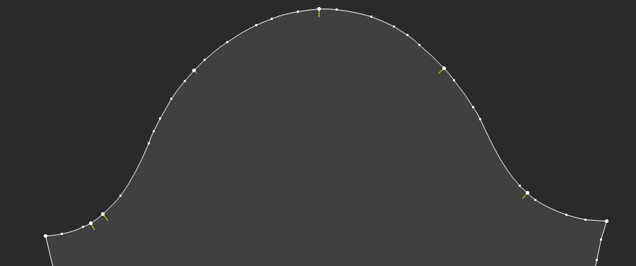

**Pkt Bags:**

Make piece for YY when cut in self, If cut in lining usually no need, call out to tech pkt is not included in pattern.

4 pkt bag pieces for YY, 1 to send to Factory for basic pkt. Consider construction, pkt facings etc for YY.

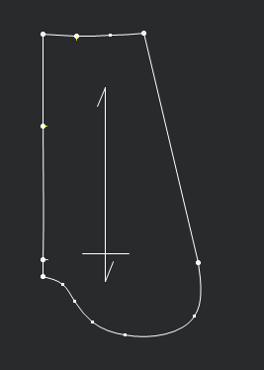

**Belt Loops:**

Make one long piece + seam allowance with piece on fold and bias for YY - will not include in pattern factory to make as needed.

**Clo only pieces:**

Delete clo only blind pieces

If piece is split for hems or ruffles put back together correct size.

Delete unnecessary lines – for example fold line on collar.

**Knits:**

**Rib bands:** Rib bands may look good in clo, but call out to factory adjust stretch to lay flat on wearer. Ribs bands must be cut straightfor pattern to send to factory.

**\*\*Provide tech basic pattern measurements.**

**Construction: Tech to advise construction for clo styles.**

**Any construction changed in virtual fit or otherwise should be corrected on set up by tech, 3D tech should call out to tech to check discrepancies.**

**Please do not send conflicting info to the vendor.**

**Do not send set up with specs from design or specs in POM page if they would contradict pattern.**

**Use basic pattern measurements advised from pattern out of clo fit.**